Roles and Users:
Assignment 1: Snowflake Environment Setup (Beginner)
Objective: Understand Snowflake UI and basic objects.
Tasks
- Log in to Snowflake (trial account).
- Create:
  - A Database
Create or replace database training_db;

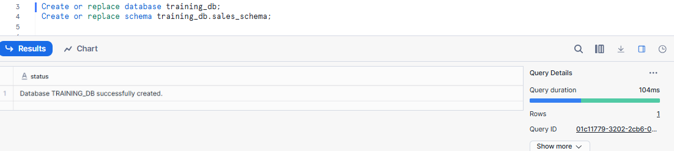

  - A Schema
Create or replace schema training_db.sales_schema;
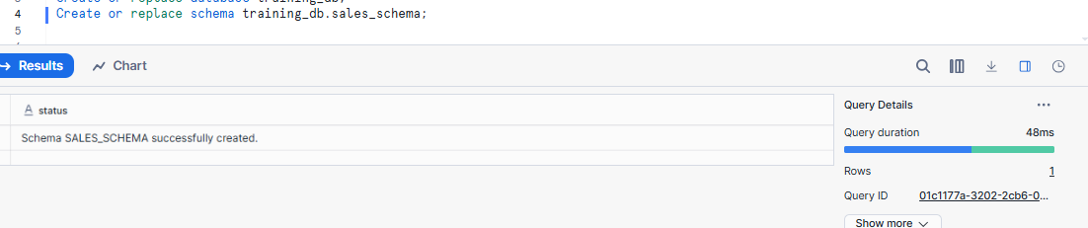
  - A Virtual Warehouse
A Virtual Warehouse is a compute resource in Snowflake that is used to run queries, load data, and perform transformations.
Create or replace warehouse training_wh
With
Warehouse_size = 'xsmall'
Auto_suspend = 60
Auto_resume = true;
X-SMALL is the smallest Snowflake virtual warehouse size, used for low-cost, low-compute workloads.

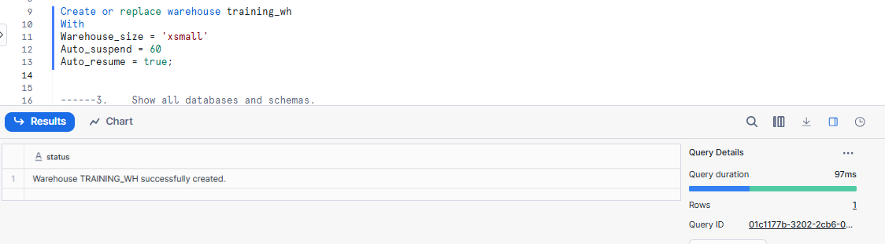

--Showing All Databases
show databases;

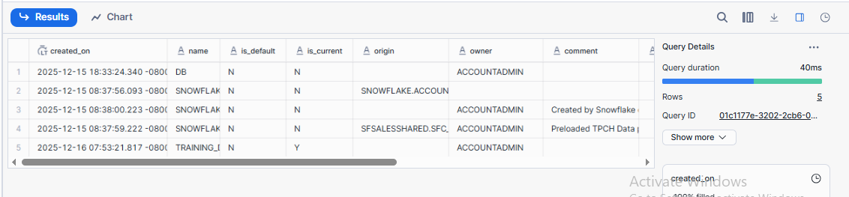

----Showing all schemas
Show Schemas
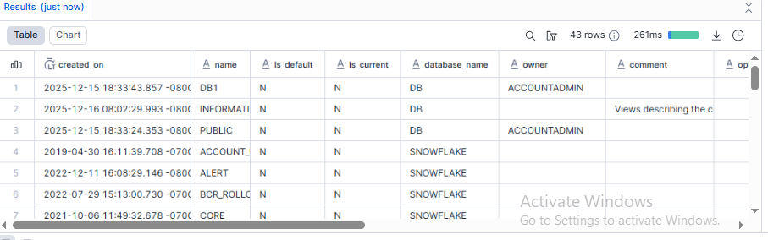

- Suspend and resume the warehouse.
AUTO_SUSPEND automatically stops a virtual warehouse after a period of inactivity to save cost.
AUTO_RESUME automatically starts a suspended virtual warehouse when a query is submitted.
ALTER WAREHOUSE training_wh SUSPENDED;

ALTER WAREHOUSE training_wh RESUME;

Deliverable:
- SQL script
- Screenshot of created objects

Assignment 2: User, Role & Access Control (RBAC)
RBAC (Role-Based Access Control)
RBAC means permissions are assigned to roles, and roles are assigned to users.
Objective: Learn Snowflake security and role hierarchy.
Tasks
- Create roles:
STUDENT_ROLE
CREATE OR REPLACE ROLE STUDENT_ROLE
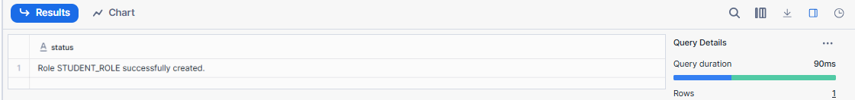
INSTRUCTOR_ROLE
CREATE OR REPLACE ROLE INSTRUCTOR_ROLE;
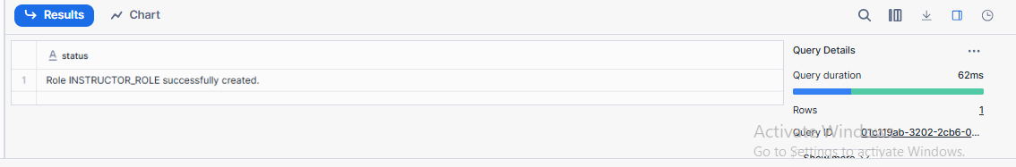
- Create users:
student1
Create or replace user student1
Password = 'student@123'
Default_role = student_role
Must_change_password = true;
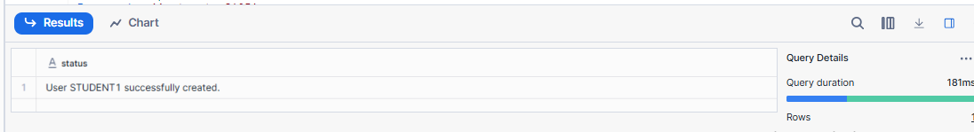
instructor1
Create or replace user instructor1
Password = 'instructor@123'
Default_role = instructore_role
Must_change_password = true;
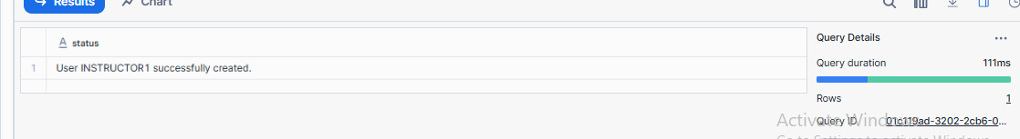
- Assign:
STUDENT_ROLE → student1
Grant role student_role to user student1;
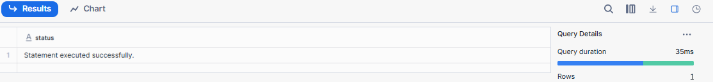
.INSTRUCTOR_ROLE → instructor1
Grant role instructor_role to user instructor1;
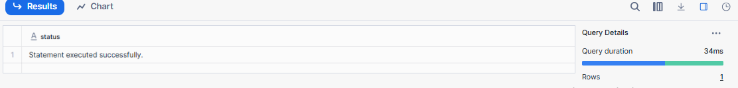
- Grant permissions:
Student → SELECT on tables
Grant select
On table training_db.sales_schema.students
To role student_role;
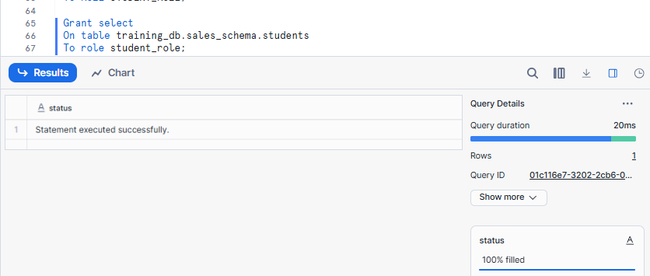

Instructor → SELECT, INSERT
GRANT SELECT, INSERT
ON TABLE training_db.sales_schema.students
TO ROLE INSTRUCTOR_ROLE;
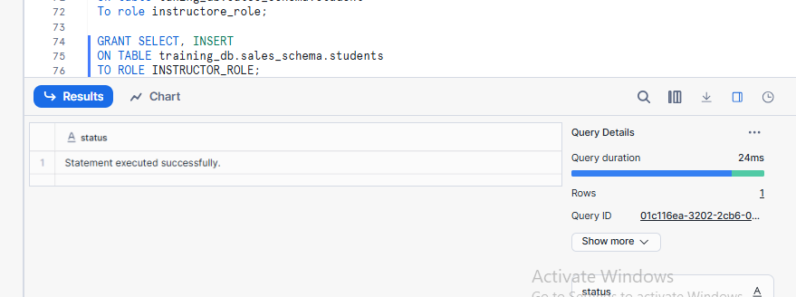

- Verify access using SHOW GRANTS.
Show grants to user student1;
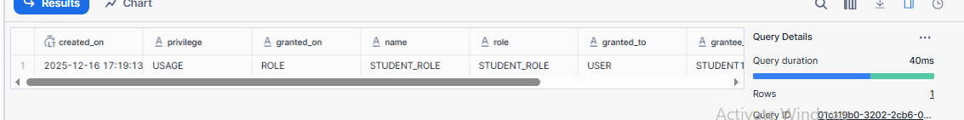
Show grants to user instructor1;
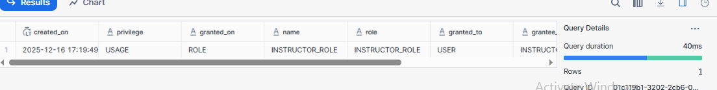

Deliverable:
- SQL commands
- Short explanation of RBAC

Assignment 3: Table Creation & Data Loading
Objective: Work with structured data.
Tasks
- Create a table:
CREATE TABLE students (
id INT,
name STRING,
course STRING,
score INT
);
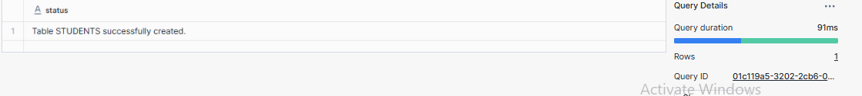
- Insert at least 10 records.
- Insert into students values
- (1, 'raji', 'Azure', 85),
- (2, 'shilpa', 'Python', 78),
- (3, 'Ramu', 'SQL', 92),
- (4, 'sneha', 'Java', 88),
- (5, 'kiran', 'salesforce', 67),
- (6, 'prem', 'SQL', 81),
- (7, 'shilpa', 'informatica', 74),
- (8, 'siva', 'datawarehouse', 90),
- (9, 'roshini', 'SQL', 60),
- (10, 'pandu', 'Java', 83);
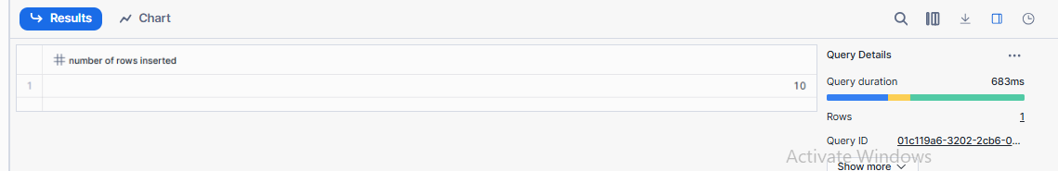

3.Query:
  - All students
select * from students;
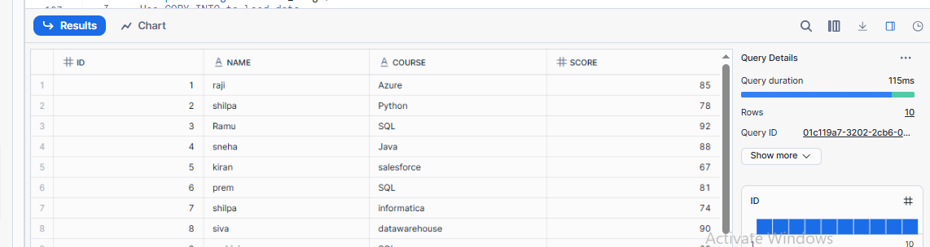

  - Students with score
  - select * from students where score > 60;
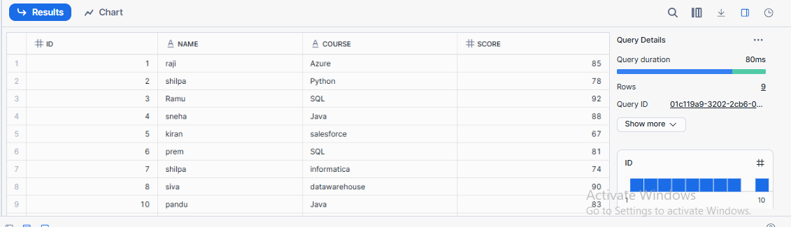

Update one record.
update students set score = 80 where id = 1;
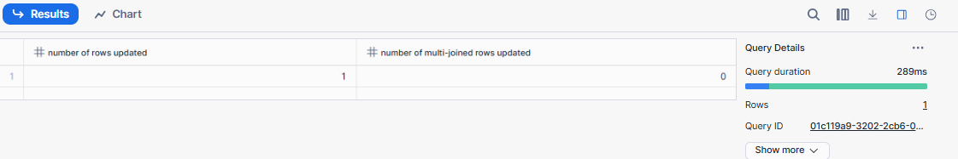

Delete one record.
delete from students where id = 9;
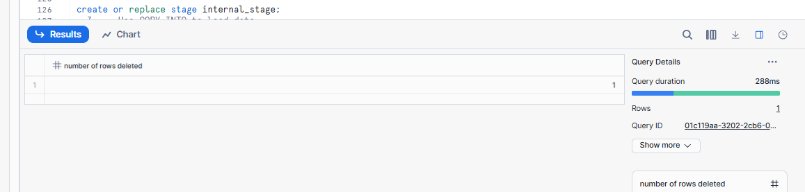
Deliverable:
- SQL file with queries
- Output screenshots

Assignment 4: File Loading using Stage & COPY (Intermediate)
Objective: Learn Snowflake data ingestion.
Tasks
- Create an internal stage.
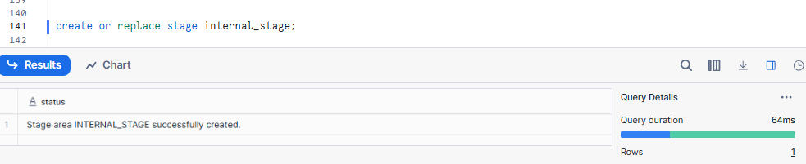
- Upload a CSV file.
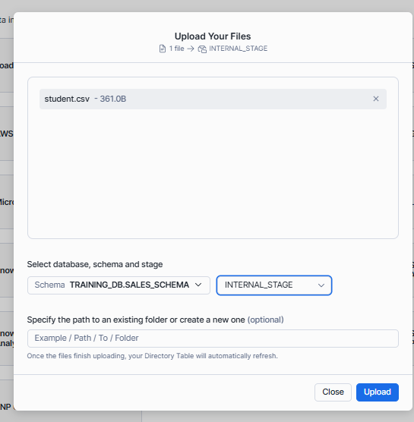

- Use COPY INTO to load data.
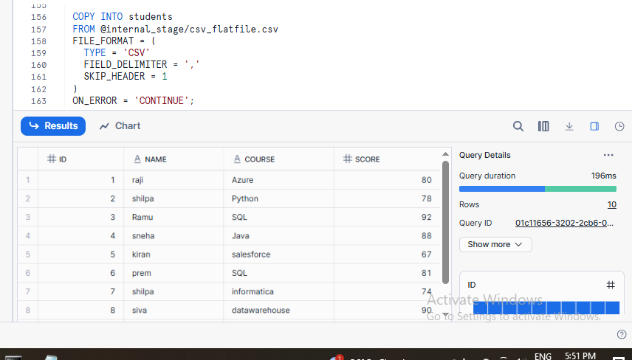
- Validate loaded records.
Select count (*) from students;

- Handle one data error using VALIDATION_MODE.
VALIDATION_MODE is used with COPY INTO to validate data files before loading them into a table.

COPY INTO students
FROM @internal_stage/students_error.csv
FILE_FORMAT = (
TYPE = 'CSV'
SKIP_HEADER = 1
)
VALIDATION_MODE = 'RETURN_ERRORS';
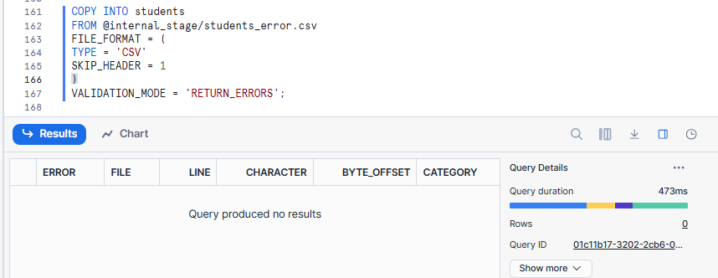
Deliverable:
- SQL script
- CSV file
- Query output

Assignment 5: Time Travel & Data Recovery
Objective: Understand Snowflake Time Travel.
Tasks
- Delete records from a table.
- Query data using Time Travel.
- Restore deleted data.
- Explain how Time Travel helps in recovery.
Deliverable:
- SQL queries
- Short explanation

Assignment 6: Warehouses & Performance
Objective: Learn compute management.
Tasks
- Create:
  - SMALL_WH
  - MEDIUM_WH
- Run same query on both warehouses.
- Compare execution time.
- Suspend unused warehouse.
Deliverable:

- Query history screenshot
Create Small_WH
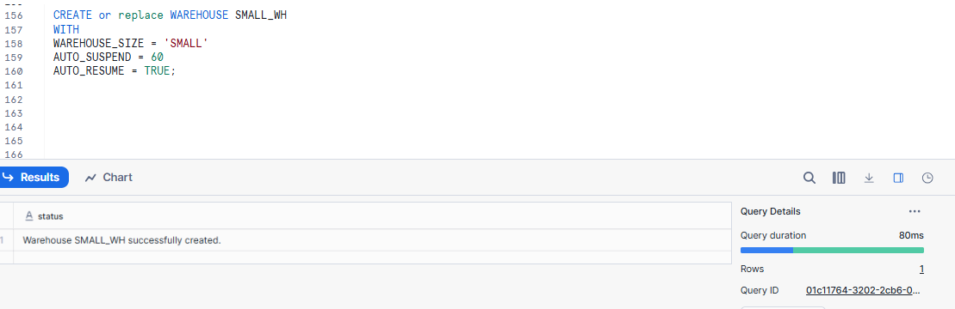
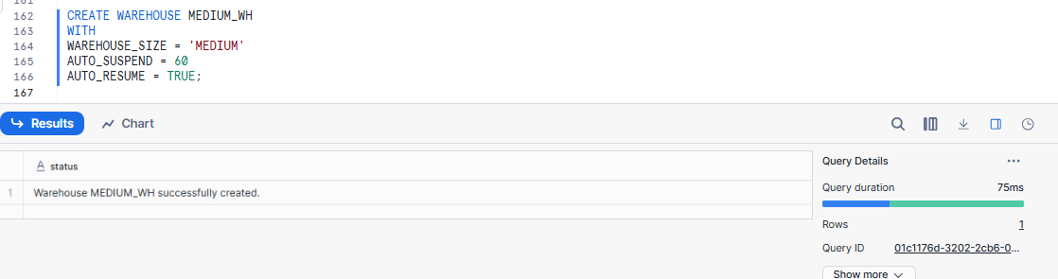
-----USE WAREHOUSE SMALL_WH;

SELECT course, COUNT(*) AS total_students
FROM training_db.sales_schema.students
GROUP BY course;
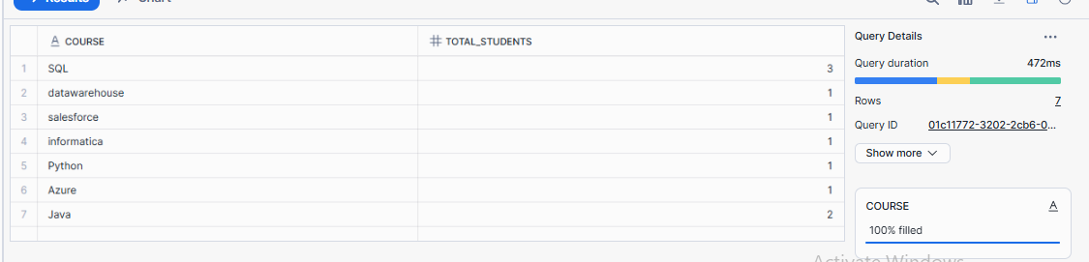
--use warehouse medium_wh;

SELECT course, COUNT(*) AS total_students
FROM training_db.sales_schema.students
GROUP BY course;

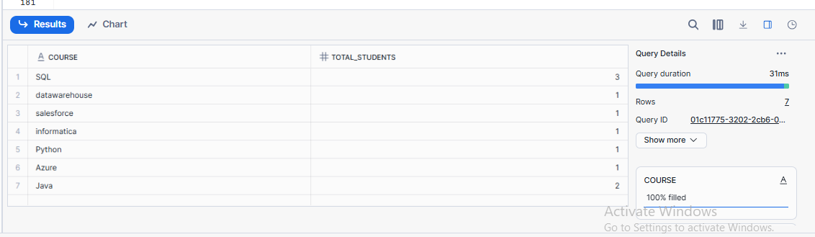

Compare execution time.
Warehouse Execution time
Small_WH ~80ms
Medium ~75ms
- Performance comparison notes

Assignment 7: Views & Secure Views
Objective: Control data visibility.
Tasks
- Create a View hiding sensitive columns.
- Create a Secure View.
- Grant view access to Student role.
- Test access using Student role.
Deliverable:
Answers:-
use database training_db;
CREATE TABLE students_full (
id INT,
name STRING,
course STRING,
score INT,
email STRING
);

INSERT INTO students1
VALUES
(1, 'shilpa', 'snowflake', 70, 'rajishilpa123@gmail.com');
1.Create a View hiding sensitive columns.
create or replace view security_view as
select id,name,course,score
from students1;
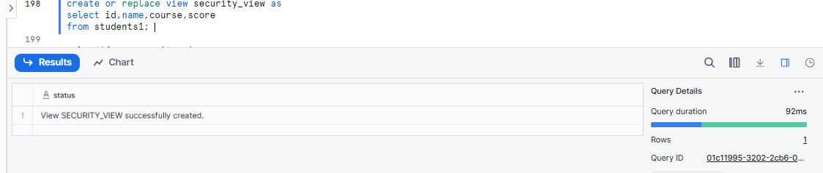
select*from security_view;
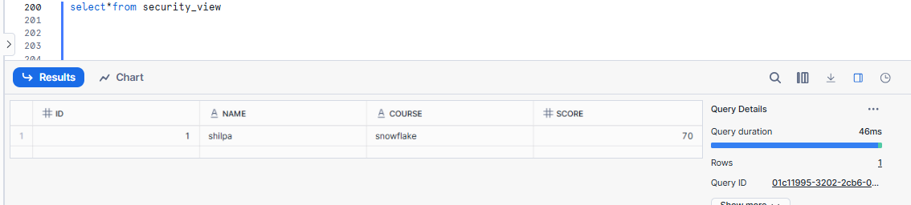
2.Create a Secure View.
CREATE OR REPLACE SECURE VIEW student_secure_view AS
SELECT id,name FROM students1;

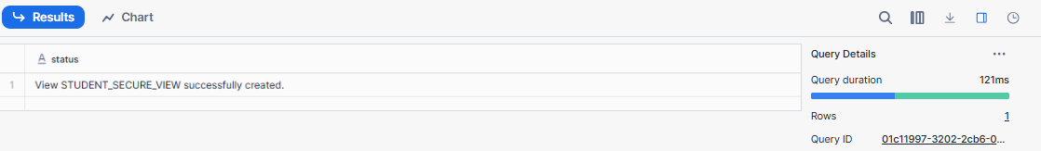
3. Grant view access to Student role.
GRANT SELECT ON VIEW student_secure_view
TO ROLE student_role;
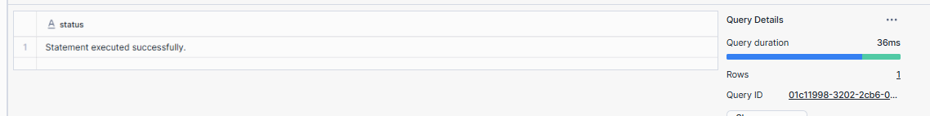

- Explanation of Secure View

Assignment 8: Scaling & Auto Suspend (Advanced)
Objective: Understand Snowflake scaling behavior.
Tasks
- Enable auto-suspend and auto-resume.
- Configure multi-cluster warehouse.
- Simulate concurrent queries.
- Observe scaling behavior.
Deliverable:
- Warehouse configuration
- Query history evidence
1.Enable auto-suspend and auto-resume.
AUTO-SUSPEND and AUTO-RESUME are enabled using ALTER WAREHOUSE to automatically stop and start compute resources, optimizing cost.

ALTER WAREHOUSE SMALL_WH
SET
AUTO_SUSPEND = 60, -- suspend after 5 minutes of inactivity
AUTO_RESUME = TRUE;
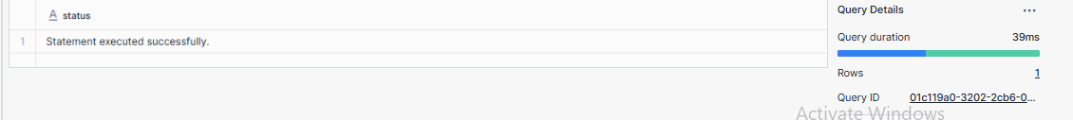

2.Configure multi-cluster warehouse.
A multi-cluster warehouse allows Snowflake to scale out (horizontally) by adding or removing clusters automatically based on query concurrency.

CREATE OR REPLACE WAREHOUSE MULTI_CLUSTER_WH
WITH
WAREHOUSE_SIZE = SMALL
WAREHOUSE_TYPE = STANDARD
MIN_CLUSTER_COUNT = 1
MAX_CLUSTER_COUNT = 3
SCALING_POLICY = STANDARD
AUTO_SUSPEND = 60
AUTO_RESUME = TRUE;

